1st program no output
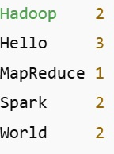
2nd program output 3rd program output
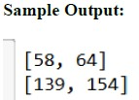

4th 5th and 6th program at last. No 8th output

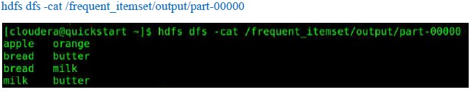
7th program output

9th program output
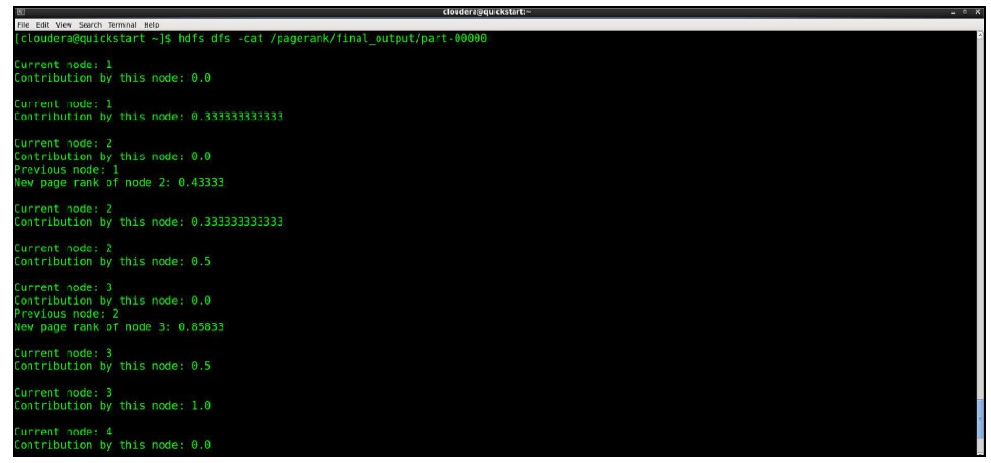
10th program
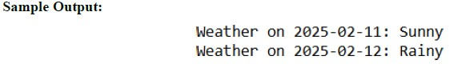

4th program output
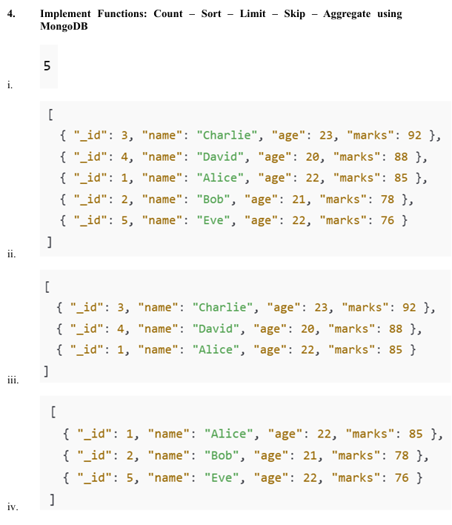
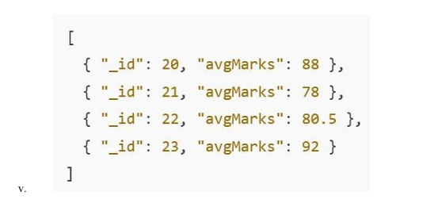

5th program output
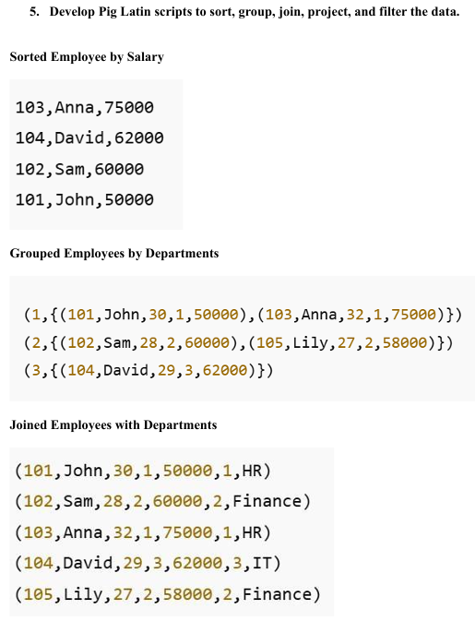

6th program output
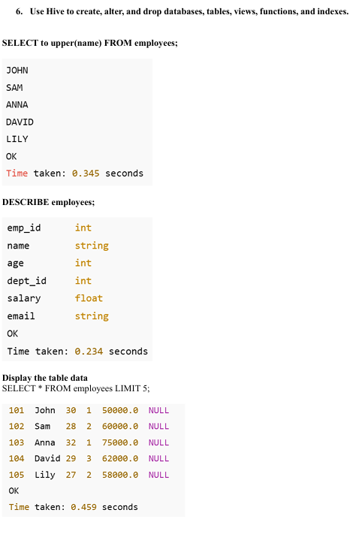

BD 10th PROGRAM
Write this in weather.txt
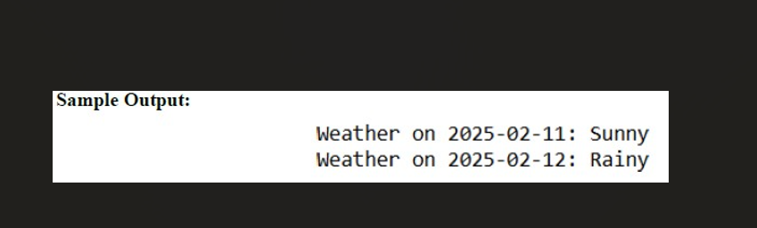
# Mapper
def mapper(line):
date, condition = line.strip().split(',')
return (date, condition)

# Reducer
def reducer(date, conditions):
count = {}
for c in conditions:
count[c] = count.get(c, 0) + 1
return (date, max(count, key=count.get))

# Driver
def main(file):
lines = open(file).readlines()

mapped = [mapper(line) for line in lines]

grouped = {}
for date, cond in mapped:
grouped.setdefault(date, []).append(cond)

for date, conds in grouped.items():
d, result = reducer(date, conds)
print(f"Weather on {d}: {result}")

# Run
if _name_ == "_main_":
main("weather.txt")
DL 3RD PROGRAM
import numpy as np
def mse(y_true, y_pred):
return np.mean((y_true - y_pred) ** 2)

def categorical_cross_entropy(y_true, y_pred):
y_pred = np.clip(y_pred, 1e-15, 1 - 1e-15)
return -np.mean(np.sum(y_true * np.log(y_pred), axis=0))

y_true = np.array([[1, 0, 0],
[0, 1, 0]]).T

y_pred = np.array([[0.7, 0.2, 0.1],
[0.1, 0.8, 0.1]]).T

print("Mean Squared Error:", mse(y_true, y_pred))
print("Categorical Cross Entropy:", categorical_cross_entropy(y_true, y_pred))

DL 5th program
import numpy as np

# Sigmoid activation
def sigmoid(x):
return 1 / (1 + np.exp(-x))

class NeuralNet:
def _init_(self, lr=0.1):
np.random.seed(42)
self.lr = lr

# Weights and biases
self.W1 = np.random.randn(4, 2)
self.b1 = np.zeros((4, 1))
self.W2 = np.random.randn(1, 4)
self.b2 = np.zeros((1, 1))

def forward(self, X):
self.Z1 = self.W1 @ X + self.b1
self.A1 = np.maximum(0, self.Z1) # ReLU
self.Z2 = self.W2 @ self.A1 + self.b2
self.A2 = sigmoid(self.Z2) # Sigmoid
return self.A2

def backward(self, X, Y):
m = Y.size

dZ2 = self.A2 - Y
dW2 = (dZ2 @ self.A1.T) / m

dZ1 = (self.W2.T @ dZ2) * (self.A1 > 0)
dW1 = (dZ1 @ X.T) / m

# Update weights
self.W2 -= self.lr * dW2
self.W1 -= self.lr * dW1

def train(self, X, Y, epochs=4000):
for i in range(0, epochs + 1, 200):
out = self.forward(X)
loss = np.mean((Y - out) ** 2)
self.backward(X, Y)
print(f"Epoch {i} | Loss: {loss:.5f}")

# ---- Training ----
X = np.array([[0, 0, 1, 1],
[0, 1, 0, 1]])

Y = np.array([[0, 1, 1, 0]])

nn = NeuralNet(lr=0.1)
nn.train(X, Y)

print("\nPredictions:")
print(nn.forward(X).round(3))

